Erik Marrero

CS 152-01

Homework 2

3/30/2020

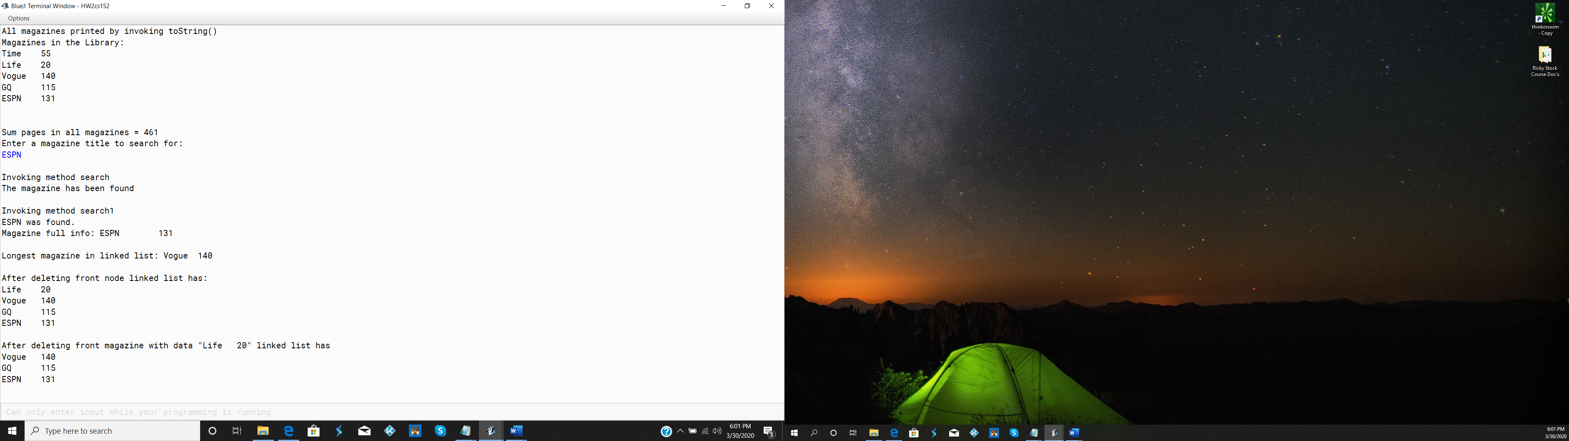

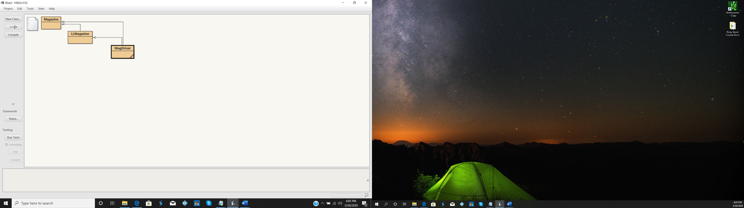

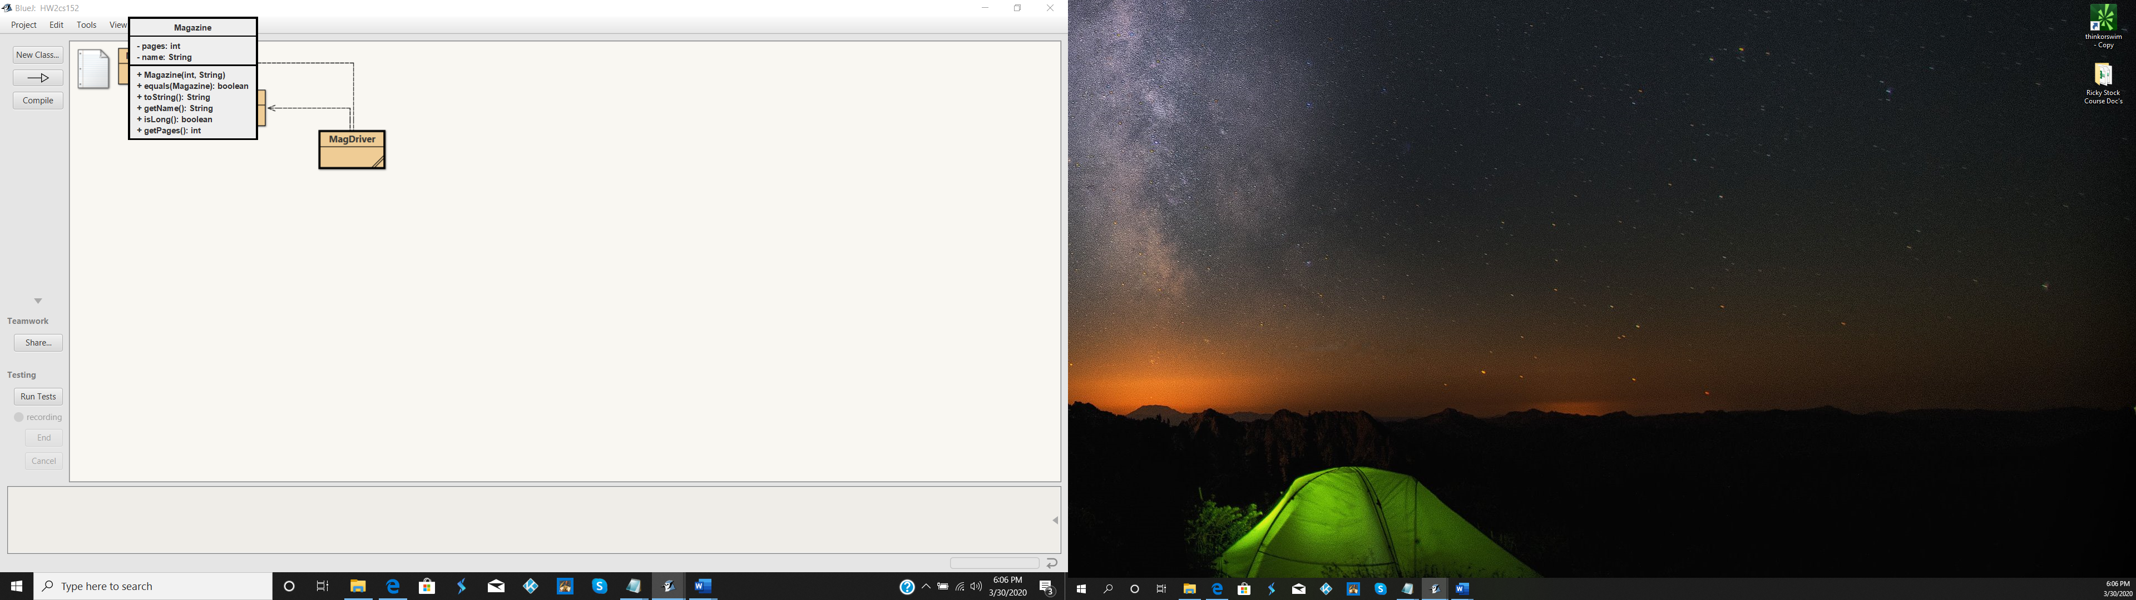

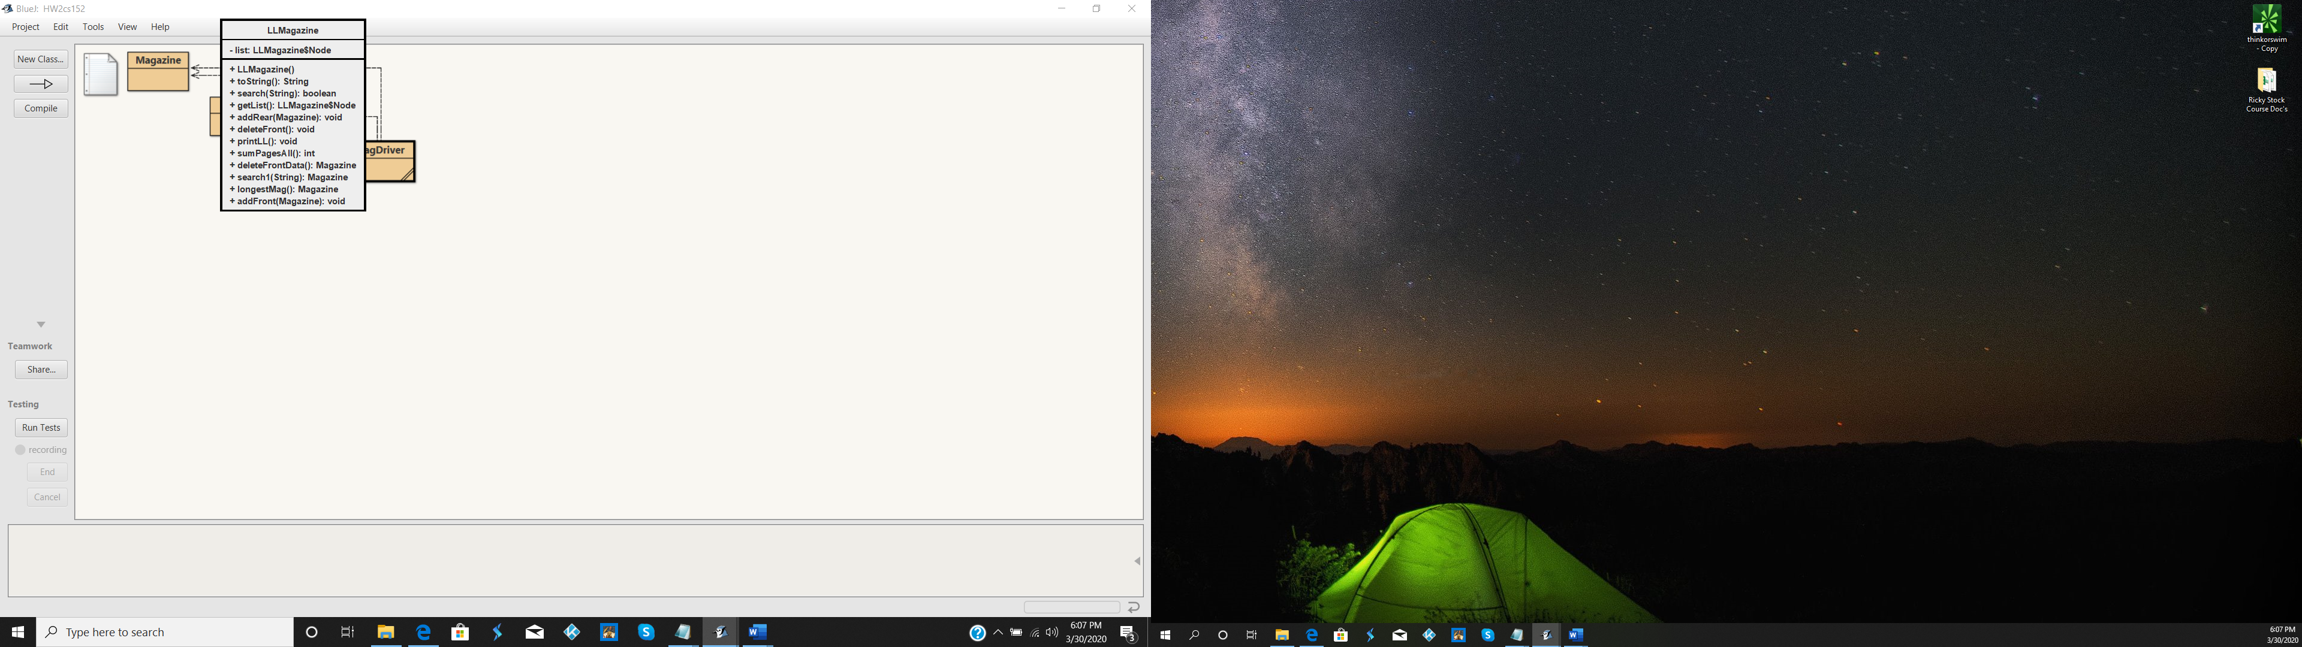

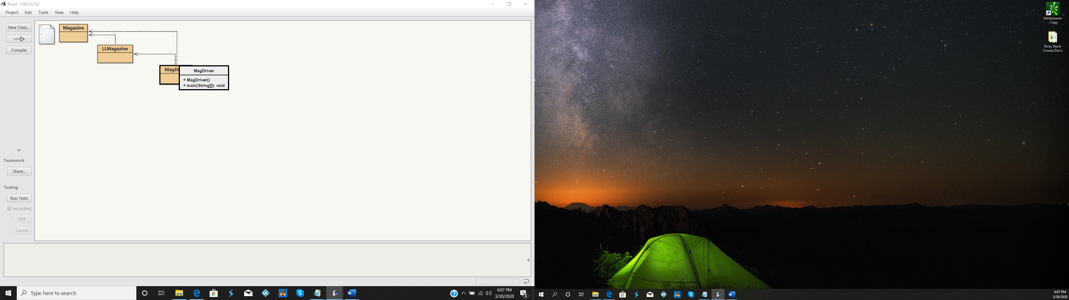

public class Magazine

{

private int pages;

private String name;

public Magazine(int p, String n)

{

pages = p;

name = n;

}

public int getPages()

{

return pages;

}

public String getName()

{

return name;

}

public boolean equals(Magazine mag)

{

return (mag.getPages() == pages &&

mag.getName().equals(name));

}

public boolean isLong()

{

return pages > 100;

}

public String toString()

{

return name + "\t" + pages;

}

}

public class LLMagazine

{

private Node list;

public LLMagazine()

{

list = null;

}

public Node getList()

{

return list;

}

public void addFront(Magazine mag)

{

Node node = new Node(mag);

node.next = list;

list = node;

}

public void addRear(Magazine mag)

{

Node node = new Node(mag);

if (list == null)

list = node;

else

{

Node curr = list;

while (curr.next != null)

curr = curr.next;

curr.next = node;

}

}

public void deleteFront()

{

list = list.next;

}

public Magazine deleteFrontData()

{

Magazine temp = list.data;

list = list.next;

return temp;

}

public void printLL()

{

Node current = list;

while (current != null)

{

System.out.println(current.data.toString());

current = current.next;

}

}

public int sumPagesAll()

{

int sum = 0;

Node current = list;

while (current != null)

{

sum += current.data.getPages();

current = current.next;

}

return sum;

}

public boolean search(String magName)

{

Node cur = list;

boolean found = false;

while (cur != null && !found)

{

if (cur.data.getName().equals(magName))

found = true;

else

cur = cur.next;

}

if (found)

return true;

else

return false;

}

public Magazine search1(String magName)

{

boolean found = false;

Node current = list;

Magazine mag = null;

while (current != null && !found)

{

if (current.data.getName().equals(magName))

{

found = true;

mag = current.data;

}

current = current.next;

}

return mag;

}

public String toString()

{

String reternStr = "Magazines in the Library:\n";

Node cur = list;

while (cur != null)

{

reternStr += cur.data.getName() + "\t" + cur.data.getPages() + "\n";

cur = cur.next;

}

return reternStr;

}

public Magazine longestMag()

{

Node cur = list;

Magazine longest = null;

while (cur != null)

{

if (longest == null || (cur.data.getPages() > longest.getPages()))

longest = cur.data;

cur = cur.next;

}

return longest;

}

private class Node

{

public Magazine data;

public Node next;

public Node(Magazine mag)

{

data = mag;

next = null;

}

public String toString()

{

return data.toString();

}

}

}

import java.util.\*;

public class MagDriver

{

public static void main(String[] args)

{

LLMagazine library = new LLMagazine();

library.addRear(new Magazine(55, "Time"));

library.addRear(new Magazine(20, "Life"));

library.addRear(new Magazine(140, "Vogue"));

library.addRear(new Magazine(115, "GQ"));

library.addRear(new Magazine(131, "ESPN"));

System.out.println("All magazines printed by invoking printLL");

library.printLL();

System.out.println("All magazines printed by invoking toString()");

System.out.println(library.toString());

System.out.println("\nSum pages in all magazines = "

+ library.sumPagesAll());

Scanner scan = new Scanner(System.in);

System.out.println("Enter a magazine title to search for: ");

String title = scan.nextLine();

System.out.println("\nInvoking method search ");

if (library.search(title))

System.out.println("The magazine has been found");

else

System.out.println("The magazine was not found.");

System.out.println("\nInvoking method search1 ");

Magazine m = library.search1(title);

if (m == null)

System.out.println(title + " was not found.");

else

System.out.println(title + " was found. \n" +

"Magazine full info: " + m.toString());

System.out.println("\nLongest magazine in linked list: " +

library.longestMag());

library.deleteFront();

System.out.println("\nAfter deleting front node linked list has: ");

library.printLL();

System.out.println("\nAfter deleting front magazine with data \"" +

library.deleteFrontData() + "\" linked list has ");

library.printLL();

}

}